**Dataset Details**

The dataset includes the following columns:

* **Booking_ID**: A unique identifier for each hotel reservation.
* **no_of_adults**: The number of adults in the reservation.
* **no_of_children**: The number of children in the reservation.
* **no_of_weekend_nights**: The number of nights in the reservation that fall on weekends.
* **no_of_week_nights**: The number of nights in the reservation that fall on weekdays.
* **type_of_meal_plan**: The meal plan chosen by the guests.
* **room_type_reserved**: The type of room reserved by the guests.
* **lead_time**: The number of days between booking and arrival.
* **arrival_date**: The date of arrival.
* **market_segment_type**: The market segment to which the reservation belongs.
* **avg_price_per_room**: The average price per room in the reservation.
* **booking_status**: The status of the booking.

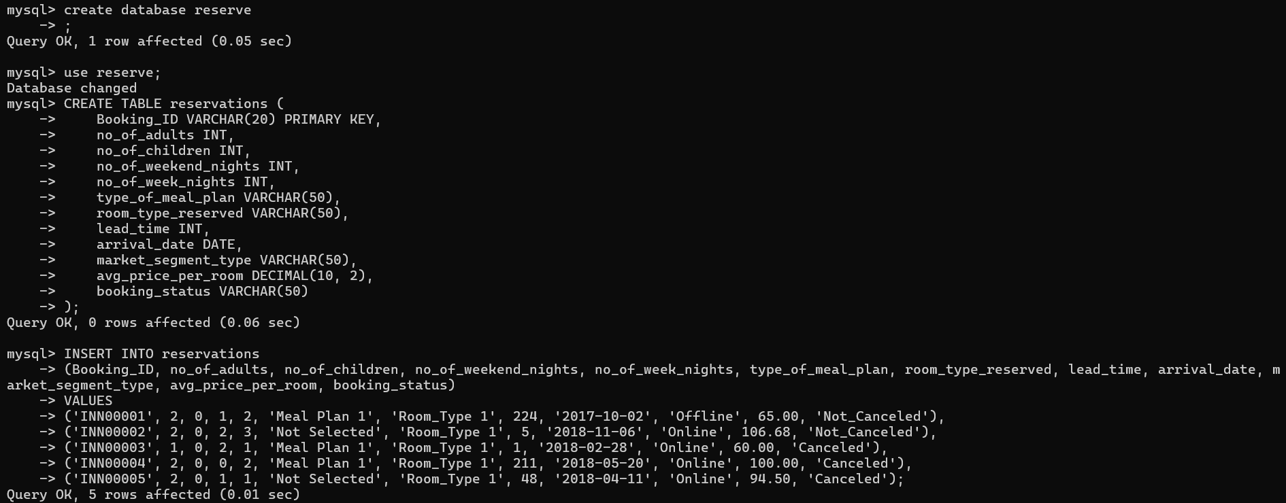

**Questions**

1. **What is the total number of reservations in the dataset?**

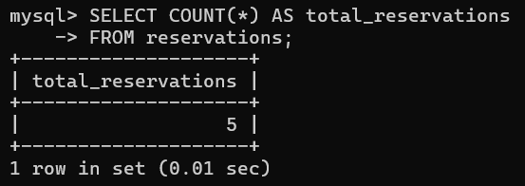

1. **Which meal plan is the most popular among guests?**

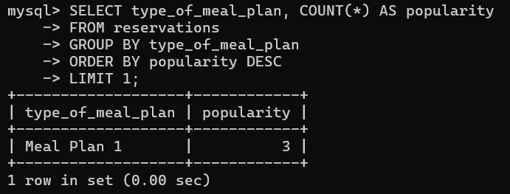

1. **What is the average price per room for reservations involving children?**

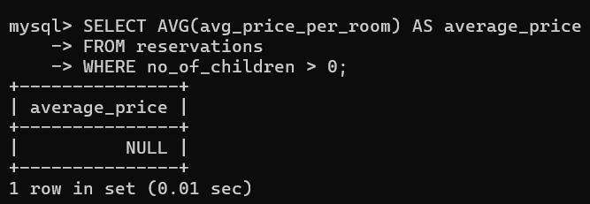

1. **How many reservations were made for the year 20XX (replace XX with the desired year)?**

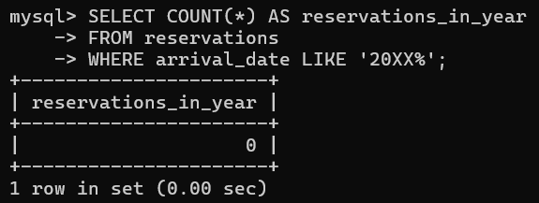

1. **What is the most commonly booked room type?**

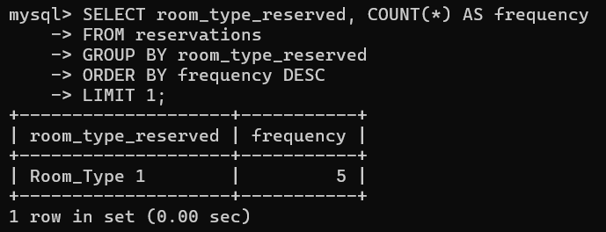

1. **How many reservations fall on a weekend (no_of_weekend_nights > 0)?**

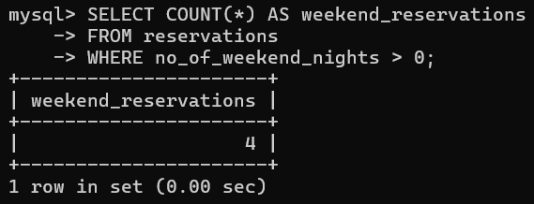

1. **What is the highest and lowest lead time for reservations?**

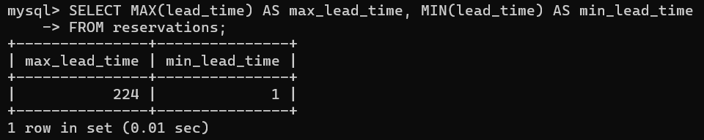

1. **What is the most common market segment type for reservations?**

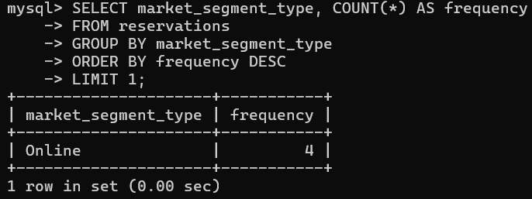

1. **How many reservations have a booking status of "Confirmed"?**

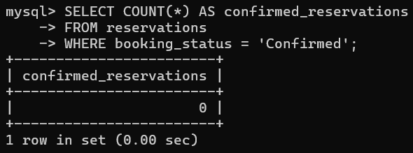

1. **What is the total number of adults and children across all reservations?**

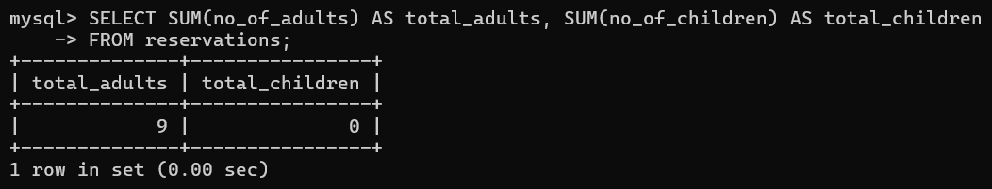

1. **What is the average number of weekend nights for reservations involving children?**

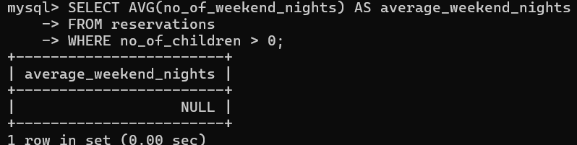

1. **How many reservations were made in each month of the year?**

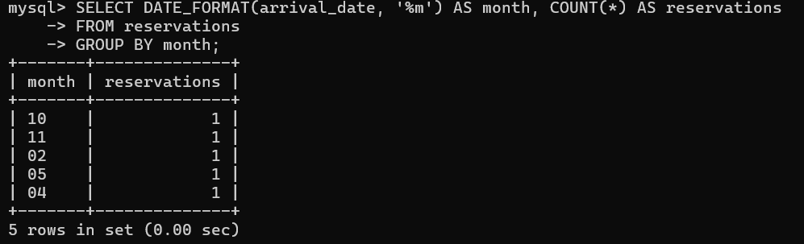

1. **What is the average number of nights (both weekend and weekday) spent by guests for each room type?**

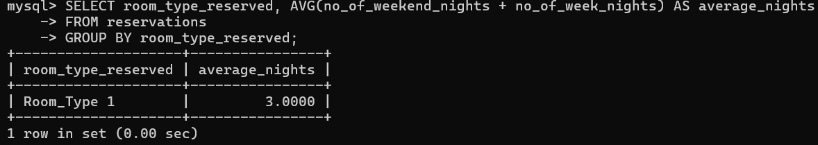

1. **For reservations involving children, what is the most common room type, and what is the average price for that room type?**

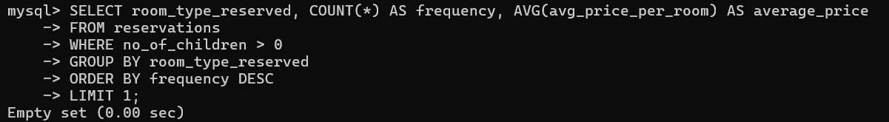

1. **Find the market segment type that generates the highest average price per room.**

